**INDEX**

|  |  |
| --- | --- |
| Practical No 01: | **Installation of Kafka.** |
| Practical No 02: | **Demonstrate Single Nodes with Single brokers.** |
| Practical No 03: | **Demonstrate Single Nodes with Multiple brokers.** |
| Practical No:04 | **Demonstrate Single Node with Multiple brokers (PYTHON)** |
| Practical No:05 | **Consumer group CLI** |

**KAFKA PRACTICAL -1**

**STEPS**

1. **Open any browser:**
2. **Search for java**



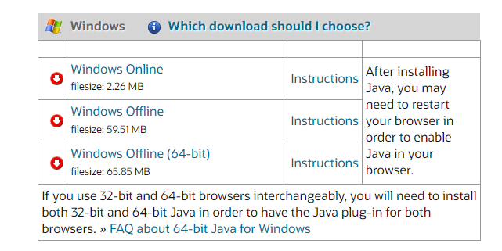

1. **Download and install java on you PC**

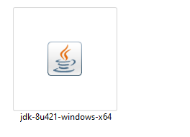

1. **Open browser**
2. **Search apache kafka download**

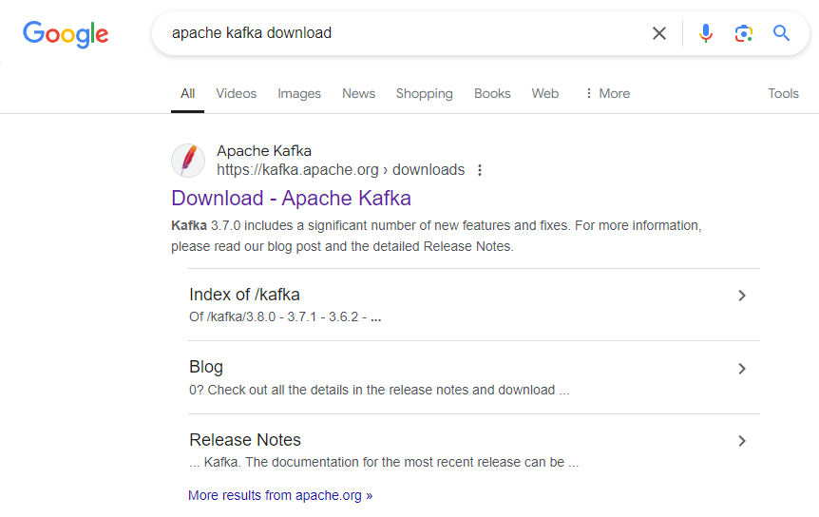

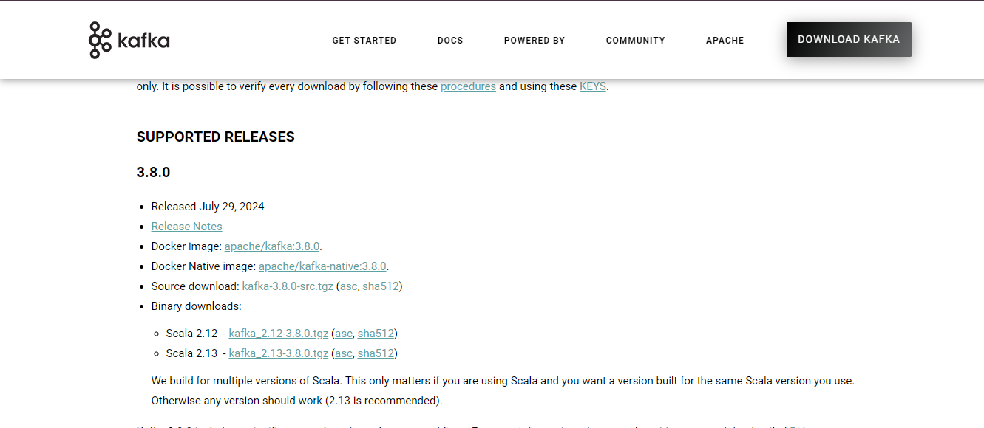



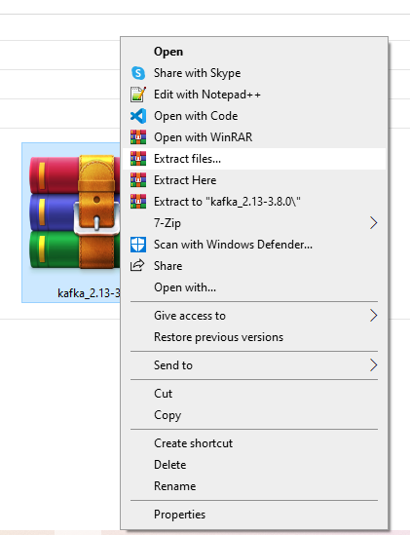

1. **After extraction rename the folder to kafka and copy and paste it to any drive you want**



1. **Open kafka folder**
2. **Open config folder**

**Open server with VS Code or notepad**

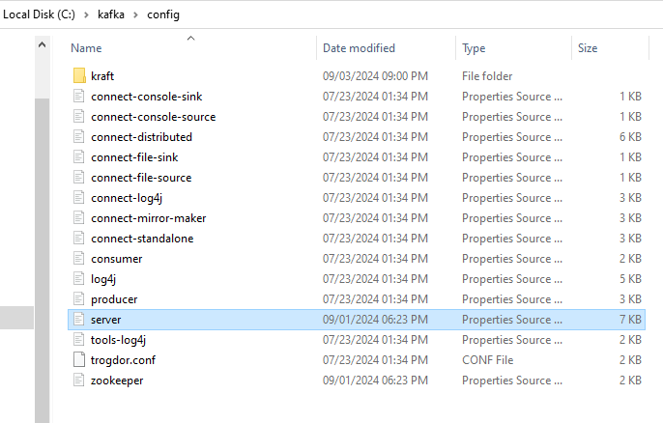

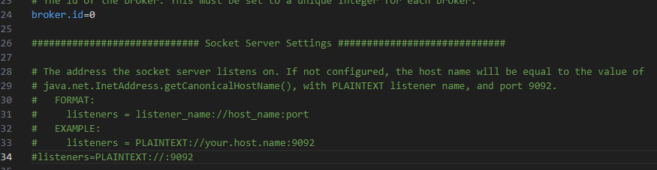

1. **Uncomment listeners**



1. **Set path to the drive your kafka folder located**



1. **Open zookeeper with VS Code or notepad**

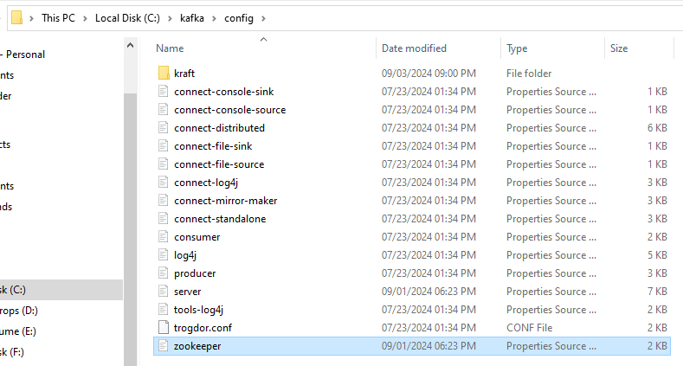

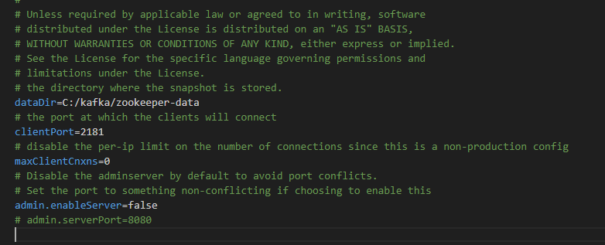

1. **Set path to drive your kafka folder located**



**########################################################################**

**Kafka Practical-2**

**Aim : Demonstrate Single Nodes with Single brokers.**

**Steps:**

1. **Go to Kafka folder**

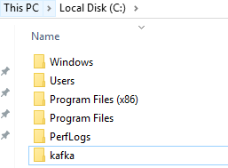

1. **Run command prompt from the kafka folder**



1. **Start zookeeper in cmd**



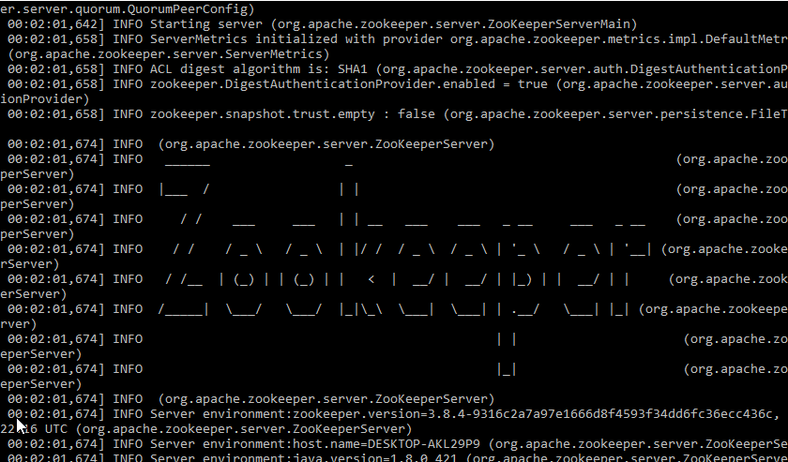

1. **Start server in cmd**



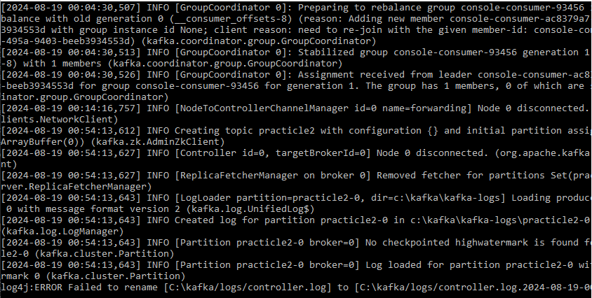

1. Start the producer from cmd

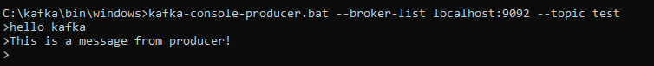

1. Start the consumer from cmd to receive messages



====================================================================================

**Kafka Practical-3**

**Aim : Demonstrate Single Node with Multiple brokers**

1. **Go to Kafka folder inside**

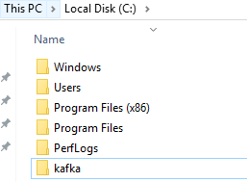

1. **Go to config file**

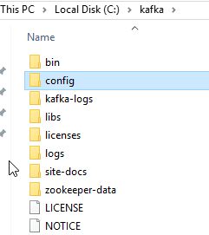

1. **Select Server.properties and make 2 copies as server1.properties & server2.properties**

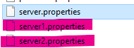

1. **Edit server1.properties with notepad++ and set broket id to 1, Listeners port number to 9093**

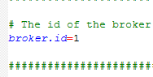



**And change the log.dirs to kafka-logs-1**



1. **Edit server2.properties with notepad++ and set broket id to 2 and listeners port number to 9094**

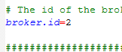

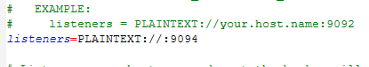

**And change the log.dirs to kafka-logs-2**



1. **Run command prompt from the kafka folder**



1. **Start zookeeper in cmd**



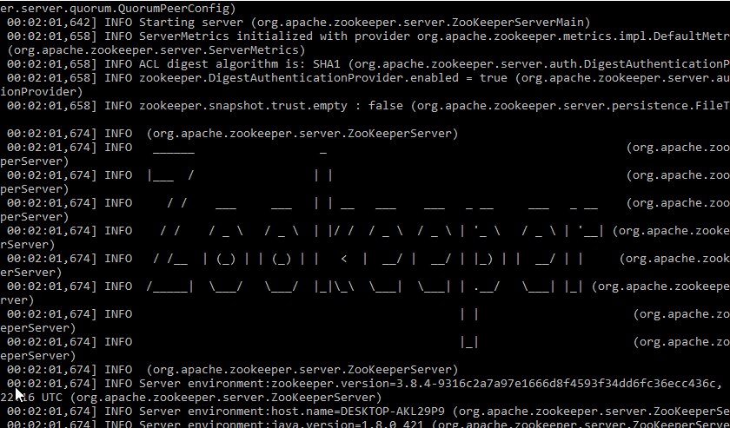

1. **Start server in cmd**



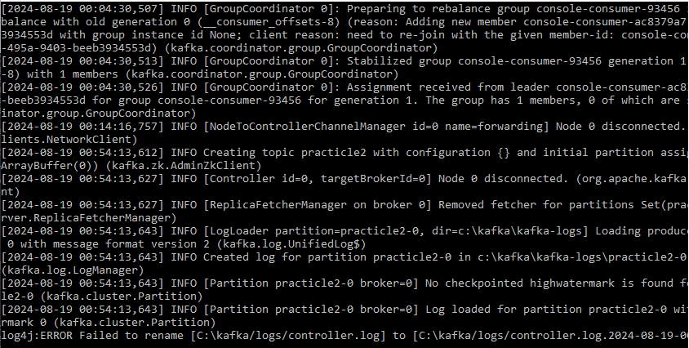

1. **Start the server1 in cmd**





1. **Start server2 in cmd**





1. **Create the topics**



1. **It will create a log file in kafka directory**

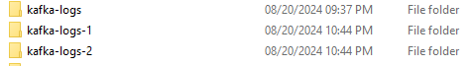

1. **With 3 partitions each**
2. 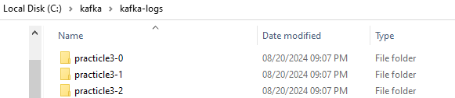
3. 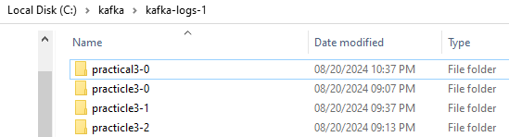
4. 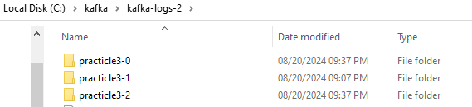
5. **Viewing the topics list**

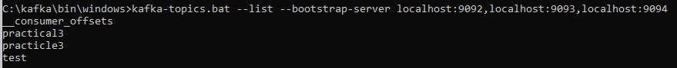

1. **Describing the topics**

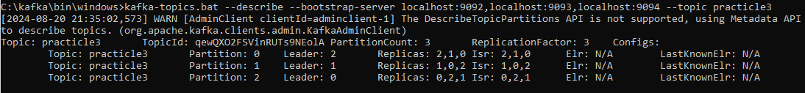

**====================================================================**

**KAFKA PRACTICAL – 4**

**Aim : Demonstrate Single Node with Multiple brokers**

**Steps:**

1. **Go to Kafka folder**



1. **Run command prompt from the kafka folder**



1. **Start zookeeper in cmd**





1. **Start server in cmd**





1. **Create the topics**





1. Create a kafka_py folder inside kafka folder

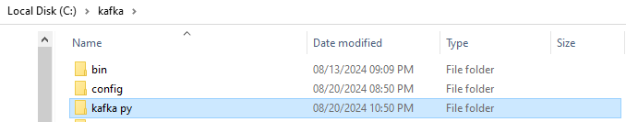

1. Install kafka for python in cmd using pip command
2. pip install kafka-python
3. pip install kafka-python-ng
4. pip install git+https://github.com/dpkp/kafka-python.git
5. Create a producer.py inside kafka_py folder with following code

Code:

from kafka import KafkaProducer

# Initialize the Kafka producer

producer = KafkaProducer(bootstrap_servers='localhost:9092')

# Send multiple messages to the topic

for i in range(10):

    producer.send('python-topic', f'Message {i}'.encode('utf-8'))

# Make sure all messages are sent

producer.flush()

print("All messages sent successfully!")



1. Create a consumer.py inside kafka_py folder with following code

Code:

from kafka import KafkaConsumer

# Initialize the Kafka consumer

consumer = KafkaConsumer(

    'python-topic',

    bootstrap_servers='localhost:9092',

    auto_offset_reset='earliest',

    enable_auto_commit=False,

    group_id='my-group'

)

# Consume messages from the topic

for message in consumer:

    print(f"Received message: {message.value.decode('utf-8')}")

    # Manually commit the offset after processing the message

    consumer.commit()



1. Run the producer.py python file from cmd





1. Run the consumer.py file from cmd



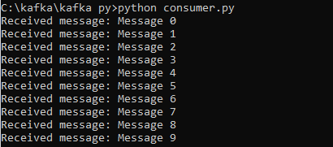

**=====================================================================================**

**KAFKA PRACTICAL – 5**

**AIM: Consumer group USING CLI**

* + 1. **Go to Kafka folder inside**



* + 1. **Run command prompt from the kafka folder**



* + 1. **Start zookeeper in cmd**





1. **Start server in cmd**





1. **Create topics**

**kafka-topics.bat --bootstrap-server localhost:9092 --create --topic my-topic --partitions 1 --replication-factor 1**



1. **Start producer and send some messages first**

**kafka-console-producer.bat --broker-list localhost:9092 --topic my-topic**

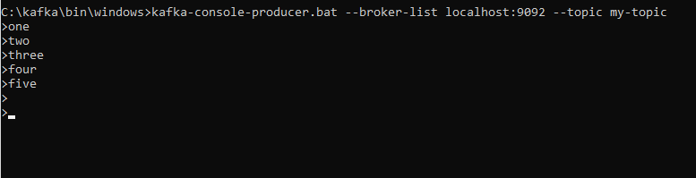

1. Now start the consumer group
2. This will be the First consumer of the group

kafka-console-consumer.bat --bootstrap-server localhost:9092 --topic my-topic --group my-group --from-beginning

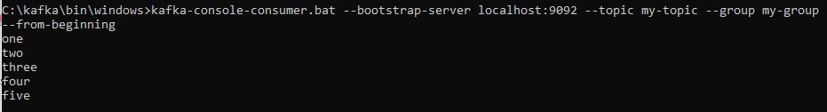

1. Start one more consumer group
2. This will be the second consumer of the group

kafka-console-consumer.bat --bootstrap-server localhost:9092 --topic my-topic --group my-group --from-beginning

1. Now continue messaging in producer
2. The second consumer will read the new messages

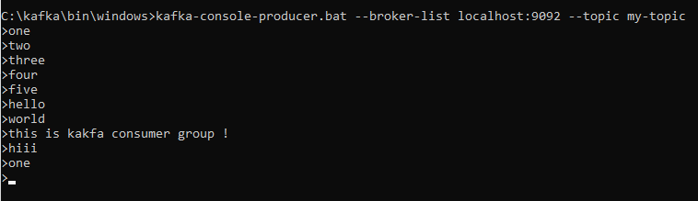

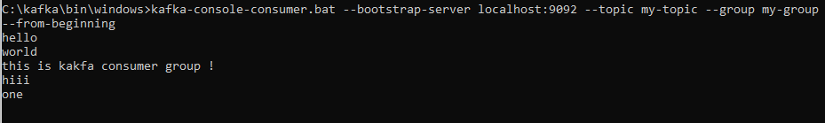

1. In case of new consumer not reading the message
2. Reset the offset in new CMD using the following command

kafka-consumer-groups.bat --bootstrap-server localhost:9092 --group my-group --reset-offsets --to-earliest --execute --all-topics

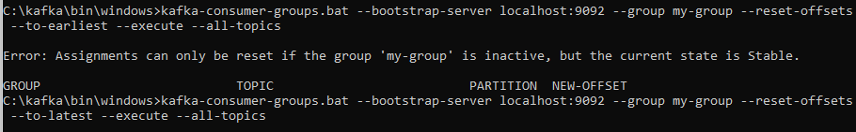

1. To describe the offset

kafka-consumer-groups.bat --describe --bootstrap-server localhost:9092 --group my-group



1. To see how many groups was created

kafka-consumer-groups.bat --list --bootstrap-server localhost:9092



1. To delete the group

kafka-consumer-groups.bat --bootstrap-server localhost:9092 --delete --group my-group